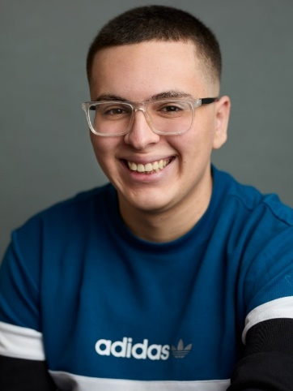

Sirag Benelhag

Mobile: +44 7931 351 491 Email: siragbenelhagacting@hotmail.com
Location: Manchester, UK Eye colour: Brown
Height: 5’8 Hair colour: Brown

Playing Age: 16-21

TV/FILM

ROLE PRODUCTION COMPANY DIRECTOR YEAR
2023
2024
Aksil-Cameron Gawor
Humber college
Fight me! (Short film)
Alex
Rifle St. Studios
Jake Greaves
Criminal Masterminds (Short film)
Frosty
Mara Jade-Rushfirth
2024
University of Salford
A love’s bite (Student film)
Lynn
Benjamin Carter-Bishop
2024
Frederick Torrance
Flat pack theatre
If you’re watching this (Short series)

Dan
2025
Leo Garside- Holdich
University of Salford
Pigs don’t lie (Student film)
Alex
2025
Toby Shepherd
Lone Oak productions
Who is she? (Student film)

THEATRE
1 Man 2 Guvnors (College Production)
Charlie Clench

2022
Kevin Rowntree
The Lowry

Embolo
Exchange 360 (High school production)
2019
Abraham Moss community school
(In association) Royal Exchange theatre

Long John Silver/Blackbeard
2022
Kevin Rowntree
Coconut Moon theatre company
Treasure Island (Abridged-college production)
Treasure

2022
Gideon Clear
Pendleton College
The Resistible Rise of Arturo Ui (College production)
Arturo Ui

Training:
Media and Performance: BA (Hons): University of Salford: 2022-2025
Film and Media production: BA (Hons): Humber College: Jan-April 2024 (Exchange)
Performing Arts (Acting) Extended Diploma Level 3: Pendleton School of Theatre: 2020-2022
GCSE Drama: Abraham Moss Community School: 2015-2020

(*= fluent/highly skilled)
Skills: APC Knife (Basic), APC Broadsword (Basic), APC Unarmed (Basic) Children’s theatre, Motion capture
Accents & Dialects: Mancunian (Native), Libyan, Heightened RP
Languages: Arabic
Sport: Football

